I am very new to web development and started using Nuxt.js about 4 months ago. I am having a hard time to have my app fetch and return the desired objects. I researched using Google, GitHub, and Youtube videos, but I have not found a solution to my issue. My app has a form with 5 input fields. Our users need to select a branch from the dropdown menu and fill out one more input field before they can search a customer(s). I am using a mock data file with 11 objects in it with 5 keys: id, branch, first name, last name, and email. Two different branches can have the same id numbers. The branch input field is required. Users My objective is to return data objects with a branch and whichever other input fields the users fill out. My issue is I can't restrict data set returned with the branch selected.
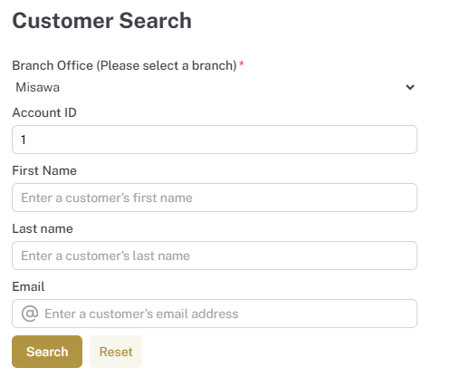
With Misawa for the branch and 1 for the Acct Id, I expect to see “No customer found” as Search Result.
When I run the code below, the app returns the Acct Id#1 with branch, Okinawa.
const queryParams = new URLSearchParams()
queryParams.append('branch', formState.branch || '')
url.value = 'https://689d3046ce755fe697880775.mockapi.io/api/mockdata/customers'
if (formState.id) {
url.value += `/${formState.id}`
} else {
if (formState.firstName) {
queryParams.append('firstName', formState.firstName)
}
if (formState.lastName) {
queryParams.append('lastName', formState.lastName)
}
if (formState.email) {
queryParams.append('email', formState.email)
}
}
const queryString = queryParams.toString()
if (queryString) {
url.value += `?${queryString}`
}
console.log('URL:', url.value)
const { data, pending } = await useFetch(url.value)
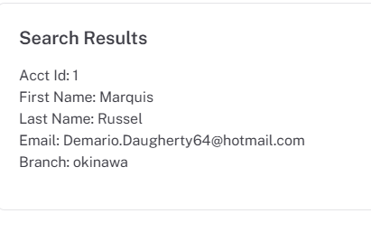
When I run the code below, I received two objects for branch, Misawa, and Acct Id, 1.
const { data, pending } = await useFetch(url.value,
{
lazy: false,
query: {
branch: formState.branch,
id: formState.id,
firstName: formState.firstName,
lastName: formState.lastName,
email: formState.email
}
})

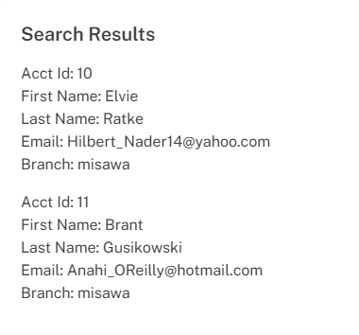
I am sure this is something very simple to overcome, but I am not experienced or knowledgeable enough to find a solution. If any of you can guide me, that would be wonderful. Thank you so much.

