RatRig Commissioning Attempt

23rd April 2025

SD CARD Preparation

Software Used

* Formatter: SDCardFormatter V5
* RATOS: 2024-07-27-RatOS-2.1.0-RC2-raspberry-rpi32.img.xz
* Imager: Balena Etcher 2.1.0.setup.exe

Result

* ‘Writer process ended unexpectedly’
* Despite numerous attempts the result remained unchanged.
* When placed in the Raspberry Pi the following appeared on the screen connected to the Pi
* 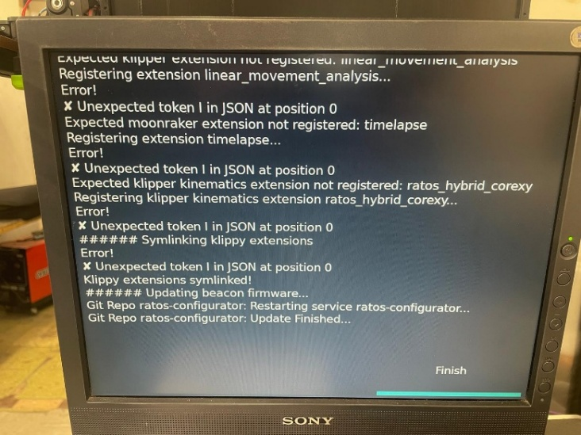

Plan B

* Raspberry Pi imager used
* 32GB card

Result

* SD card preparation was completed successfully
* Placed in Pi and powered up. A ‘bed_mesh’ error arose

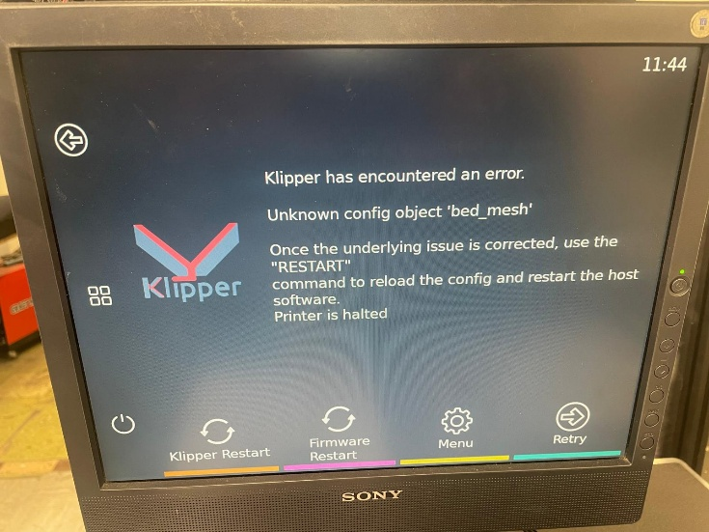

Next step

* We continued with the configuration to see if the updates would resolve issues
* Updates carried out in prescribed order:
  1. RatOS (button 10 in guide)
     + Error message related to ‘Moonraker’

* + - After pressing retry we moved to the next screen

* 1. RatOS Configurator (Button 11 in guide)
     + The configurator update stalled on this screen

* + - After refreshing the configurator we saw an error message on pi screen that showed Moonraker not connected.

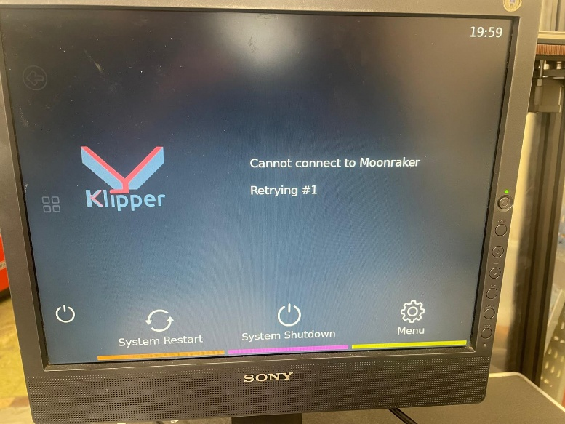

* 1. All Updates (button 12 in guide)
     + This seemed to complete okay except:
       - Klipper Update was not included and this button had to pressed after.
       - This update resulted in an error message:

Test_resonance error message actions

1. Discord shared the following:
   1. In configurator select a different printer first and then reselect correct printer.
   2. Following configurator steps but make sure that accelerometer is picked for x and Y to fix the bug.
2. During configurator we could not get past the flashing of the board stage:
   1. Automatic flashing – This option showed as unavailable
   2. Manual flashing with DFU – The board was detected but unresponsiveA screenshot of a computer

      AI-generated content may be incorrect.
   3. Manual Flashing with SD card (FAT32 and cluster size 4KB) – error message that board was undected

Data showing on Pi screen

