Tool call result

Request

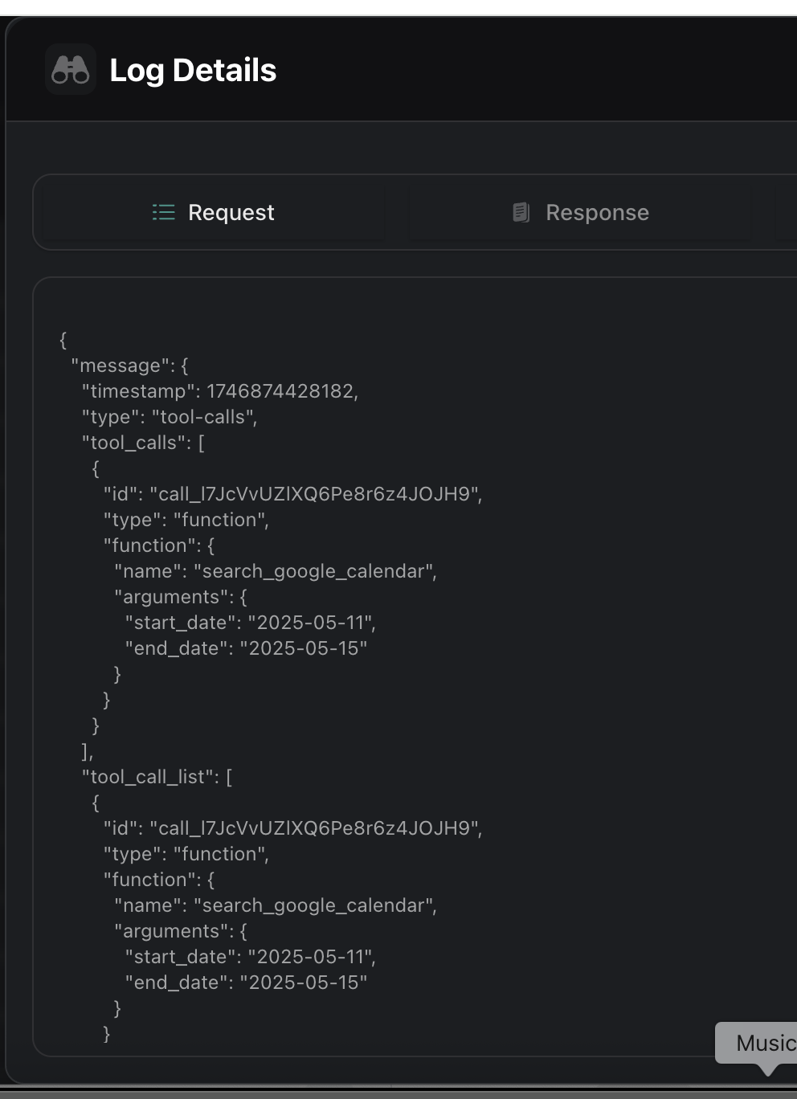

Response

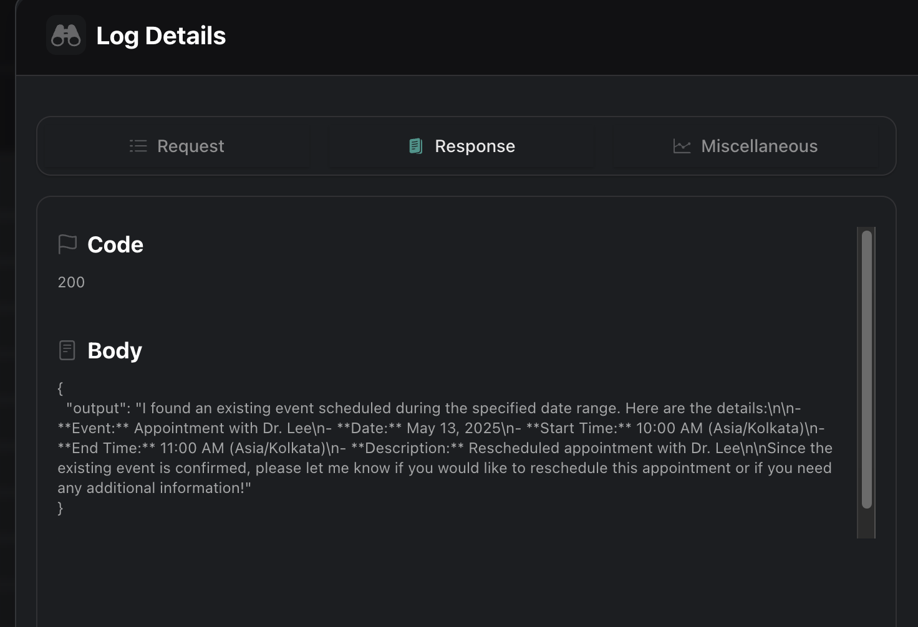

Call Log Details

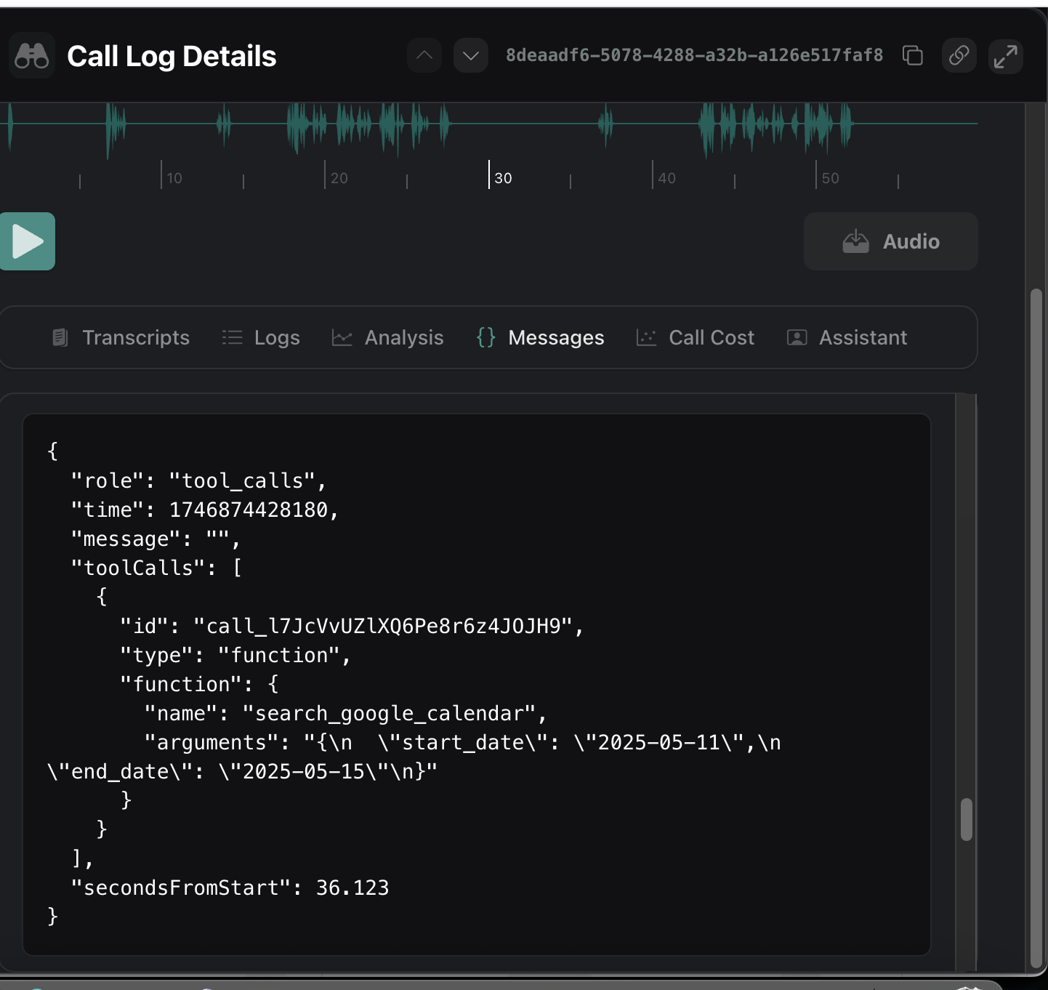

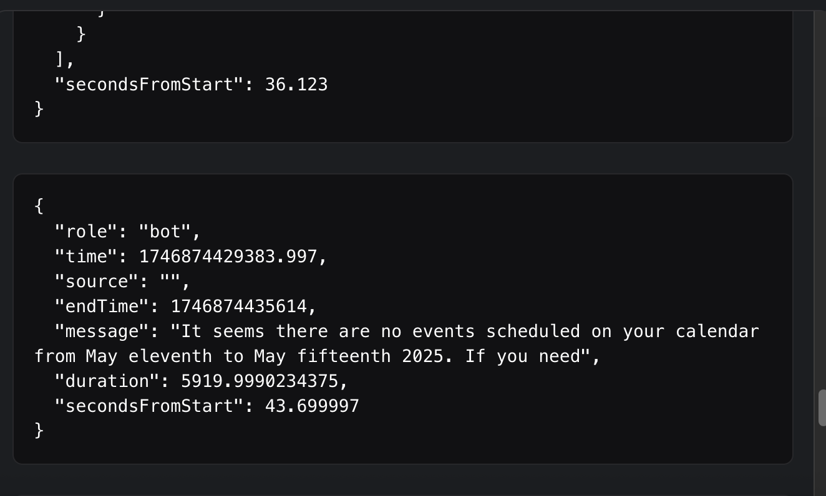

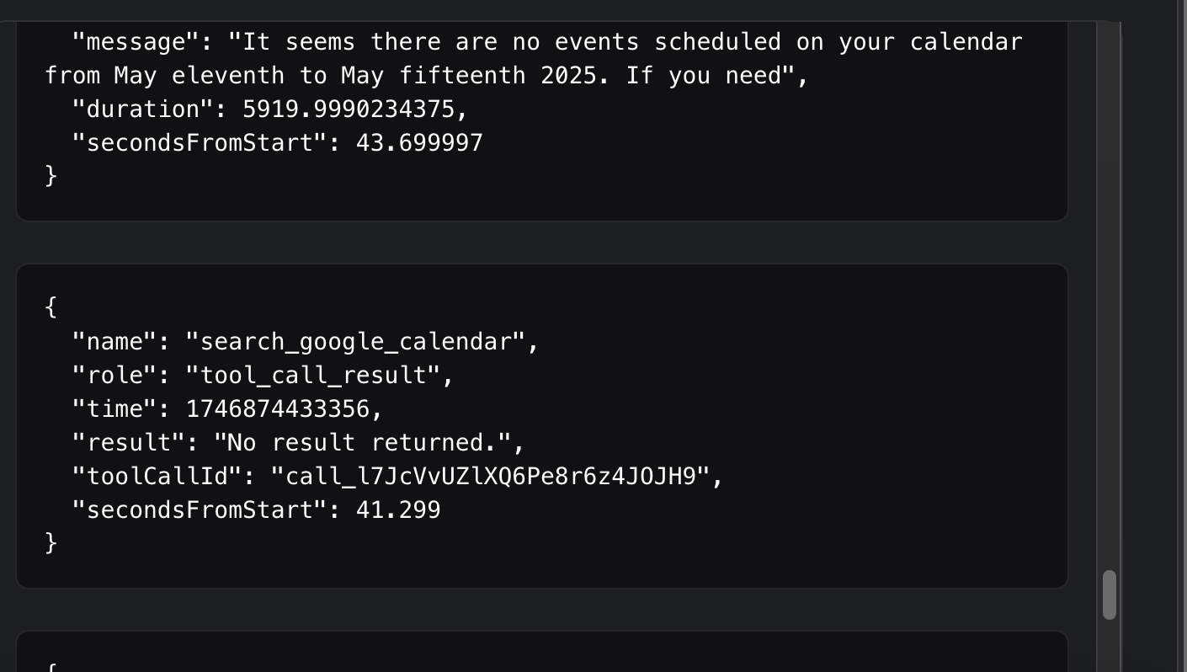

Build Details

Version
Application build and version details
Version:6a46d03fffd3de22cd9abefea861ea63dde06222
Commit:6a46d03
Branch:HEAD
Build:3837
Date:10/05/2025, 11:42:36
Channel:production

